Dear Friend of Prep,

Character, Competence, Compassion. These three words become a part of our students’ vocabulary from the moment they step through the doors of Tri-Cities Prep. These three words help shape and guide decisions that are made throughout their high school experience. Will this activity build character? Will this assignment increase competence? Will this opportunity bring compassion? These three words are at the heart of our mission. They prepare our students for success and, most importantly, they help form leaders that our community, nation and world greatly need. As the only Catholic college-prep high school in the area, we take the formation of our students very seriously.

I have the distinct pleasure of working among these students, getting to know their stories and watching them grow into impressive young men and women. I know of families who make great sacrifices to send their son or daughter to Prep. I know of Prep students who are the first in their family to go on to college. I know of Prep students who work hard to make a difference in their corner of the world, and I know of people, like you, who help them along the way. Your contribution makes a difference.

There are many organizations deserving of your support, but please know that an investment in Tri-Cities Prep brings extraordinary returns to our community, our country, and our world. That may seem a bit dramatic, but it is true. We have Prep alumni currently working in the Tri-Cities in many sectors of our economy: education, business, health care and transportation, while some are generously engaged in non-profit work that is positively impacting the developing world.

I hope you will consider supporting our Annual Appeal and help us reach our goal of $70,000. Together we can make this happen, and together we can enjoy the blessings that come from having community leaders of character, competence and compassion.

Thank you for your support of Tri-Cities Prep.

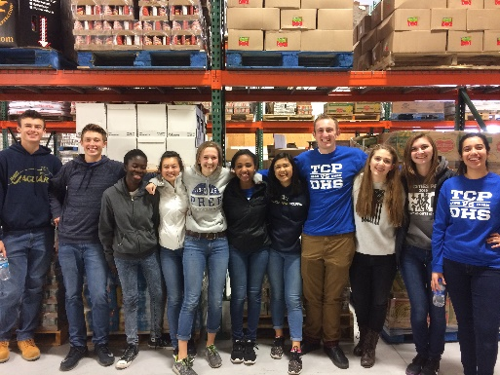
With sincere appreciation,

Lisa Jacobs
President

www.tcprep.org 9612 St. Thomas Drive, Pasco WA 509.546.2465

